What do we know about nature based tourism impacts in the Andes?
Agustina Barros, Chris Monz and Catherine Pickering
The Andes in South America are of global significance accounting for 13% of mountains worldwide. They are characterized by high regional biodiversity due to the compression of climatic zones along altitudinal gradients and extensive latitudinal gradients. They provide a range of ecosystem services, including acting as the major watershed for much of South America (Figure 1). The Andes are also increasingly popular destinations for nature based tourism. Unfortunately, along with increased visitor use comes the increased risk of negative environmental impacts
To determine the current knowledge as well as identify research gaps in recreation ecology - which is the scientific study of the impacts of nature-based tourism in the environment - we conducted a quantitative systematic literature review for the Andes region. We identified 47 recreation ecology studies, of which only 25 studies used experimental designs to demonstrate visitor impacts. The rest of the studies documented and/or acknowledged impacts through visitor management frameworks and/or interviews. Most of the experimental research was from the Southern Andes in Argentina or Chile, with just four studies from the Northern Andes (Figure 2). Studies have assessed a range of activities including hiking, camping, walking trails and wildlife watching as well as the impacts of grazing by pack animals. Most the research assessed impacts on vegetation and wildlife, with few studies on soils and/or aquatic systems. Research assessing impacts on wildlife included how emblematic species, like the Andean condor and the Guanaco responded to the presence of humans in their habitats.
The research found a wide range of impacts on soils, vegetation and wildlife from visitors in the Andes. Impacts on Andean vegetation included reductions on vegetation cover and changes in plant composition due to trails and campsites, habitat fragmentation, non native plant invasion along roads and trails and reduced plant biomass due to grazing by pack animals. Impacts on wildlife included habitat displacement and changes in the feeding behaviour of guanacos, roost abandonment by Andean condors, and reductions in bird diversity and richness in areas with high visitor use.
Despite this research there still remains a paucity of recreation ecology studies in the Andes compared to other mountain regions such as those in North America, Europe and Australia. Research in the Andes is patchy, with studies limited to a few ecoregions and protected areas and mostly focused on impacts on vegetation and wildlife. Also impacts from recreational activities such as four-wheel driving, rock climbing and adventure races, do not appear to have been assessed for the Andes.
Based on this review, research and management priorities for the Andean region include:
- Expand the geographical range of studies, including assessing visitor impacts in high conservation value areas in the Northern Andes.
- Add to the limited research on the impacts of visitors on soils and aquatic systems.
- More research on visitor related activities, including the impacts of pack animals, four wheel driving, commercial activities and adventure races.
- Integrate recreation ecology with social science research to identify visitors’ tolerance of environmental impacts from visitor use
- Determine visitor use thresholds by examining vegetation tolerance to human disturbance in different vegetation types.
- Prevent the spread of non-native plants by limiting human and pack animals disturbance and establishing weed control programs.
- Manage and regulate pack animal use in natural areas due to their greater severity of environmental impacts compared to visitors.
- Limit visitor use in areas of high conservation value including important wildlife habitats.

Regional networks, such as the American Cordillera Transect and CONDESAN, can be used as a platform for communication between researchers and conservation practitioners to implement visitor management practices based on the limited research already conducted in the Andes. Also, these and similar networks can be used to identify research priorities at the ecoregional level, which can be more cost effective and useful for conservation agencies.

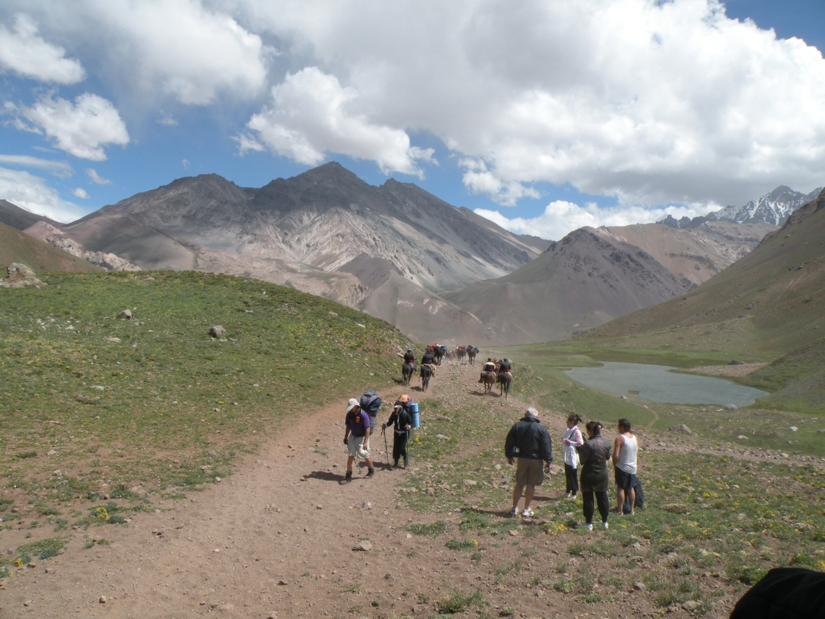
Figure 1.Visitor use in a popular protected area in the Andes region, Aconcagua Provincial Park,
Argentina.

Figure 2. Number of studies demonstrating impacts from nature based tourism and environmental components assessed in countries in the Andean region.

***
For more information about this research, please contact Agustina Barros at anaagustinabarros@gmail.com
To access to the research paper, please visit: http://link.springer.com/article/10.1007/s13280-014-0550-7.
Citation: Barros, A.; Monz, C.M., Pickering, C.M. Is tourism damaging ecosystems in the Andes? Current knowledge and an agenda for future research. AMBIO, DOI 10.1007/s13280-014-0550-7

